**Setting up the environment for installing the docker on Windows Home Version.**

To set up the environment to install the docker on windows home version follow the steps listed below.

**Manual Installation Steps**

Windows Home version does not come with pre enabled Virtual subsystem for Linux(WSL) and hence we have to manually enable it for using virtualization.

Follow the steps to Enable WLS.

**Step 1 - Enable the Windows Subsystem for Linux**

You must first enable the "Windows Subsystem for Linux" optional feature before installing any Linux distributions on Windows.

* What is WSL(Window Subsystem for Linux)?

The Windows Subsystem for Linux (WSL) is a new Windows 10 feature that enables you to run native Linux command-line tools directly on Windows, alongside your traditional Windows desktop and modern store apps.

WSL requires fewer resources (CPU, memory, and storage) than a full virtual machine. WSL also allows you to run Linux command-line tools and apps alongside your Windows command-line, desktop and store apps, and to access your Windows files from within Linux. This enables you to use Windows apps and Linux command-line tools on the same set of files if you wish.

* What is PowerShell?

PowerShell is a cross-platform task automation and configuration management framework, consisting of a command-line shell and scripting language

Open PowerShell as Administrator and run:

To do this

1. Search ‘PowerShell’ in the start menu.
2. Open the PowerShell

PowerShell Copy

dism.exe /online /enable-feature /featurename:Microsoft-Windows-Subsystem-Linux /all /norestart

We recommend now moving on to step #2, updating to WSL 2, but if you wish to only install WSL 1, you can now **restart** your machine and move on to [Step 6 - Install your Linux distribution of choice](https://docs.microsoft.com/en-us/windows/wsl/install-win10#step-6---install-your-linux-distribution-of-choice). To update to WSL 2, **wait to restart** your machine and move on to the next step.

## Step 2 - Update to WSL 2

To update to WSL 2, you must be running Windows 10.

### Requirements

* For x64 systems: **Version 1903** or higher, with **Build 18362** or higher.
* For ARM64 systems: **Version 2004** or higher, with **Build 19041** or higher.
* Builds lower than 18362 do not support WSL 2. Use the [Windows Update Assistant](https://www.microsoft.com/software-download/windows10) to update your version of Windows.

To check your version and build number, select **Windows logo key + R**, type **winver**, select **OK**. (Or enter the ver command in Windows Command Prompt). [Update to the latest Windows version](ms-settings:windowsupdate) in the Settings menu.

## Step 3 - Enable Virtual Machine feature

Before installing WSL 2, you must enable the **Virtual Machine Platform** optional feature.

Open PowerShell as Administrator and run:

PowerShell

dism.exe /online /enable-feature /featurename:VirtualMachinePlatform /all /norestart

**Restart** your machine to complete the WSL install and update to WSL 2.

**Step 4 - Download the Linux kernel update package**

1. Download the latest package:
   * [WSL2 Linux kernel update package for x64 machines](https://wslstorestorage.blob.core.windows.net/wslblob/wsl_update_x64.msi)
2. Run the update package downloaded in the previous step. (Double-click to run - you will be prompted for elevated permissions, select ‘yes’ to approve this installation.)

Once the installation is complete, move on to the next step - setting WSL 2 as your default version when installing new Linux distributions. (Skip this step if you want your new Linux installs to be set to WSL 1).

## Step 5 - Set WSL 2 as your default version

Open PowerShell and run this command to set WSL 2 as the default version when installing a new Linux distribution:

PowerShell Copy

wsl --set-default-version 2

## Step 6 - Install your Linux distribution of choice

1. Open the [Microsoft Store](https://aka.ms/wslstore) and select your favorite Linux distribution.
2. The following links will open the Microsoft store page for each distribution:
   1. [Ubuntu 16.04 LTS](https://www.microsoft.com/store/apps/9pjn388hp8c9)
   2. [Ubuntu 18.04 LTS](https://www.microsoft.com/store/apps/9N9TNGVNDL3Q)
   3. [Ubuntu 20.04 LTS](https://www.microsoft.com/store/apps/9n6svws3rx71)

Use any of the above link to install Ubuntu version of your choice.

You can also visit (<https://docs.microsoft.com/en-us/windows/wsl/install-win10>) for more information.

**STEP 7 - DOCKER INSTALLATION**

1. Docker Hub
   1. Go to hub.docker.com
   2. Sign up

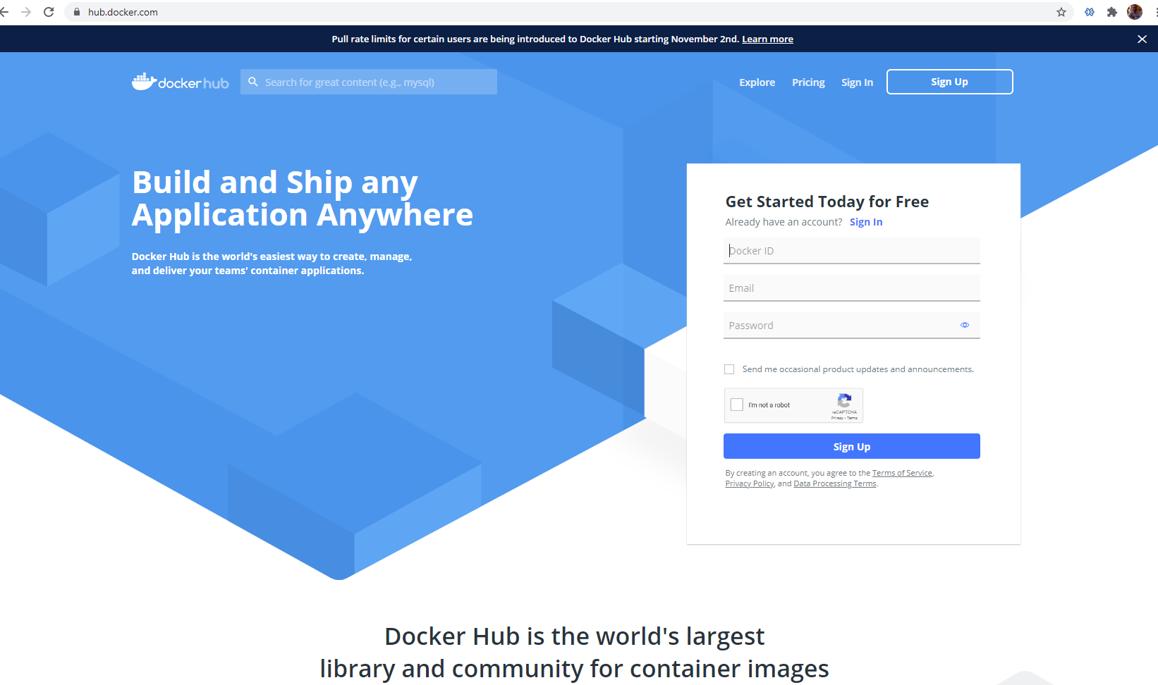

1. Download Docker
   1. Click on the tab to download docker
   2. Install the .exe file
   3. Updates
      1. You will probably get a message to install the MSI update package
         1. Go ahead and install this

**STEP 8 – DOCKER**

* 1. Now when you turn on the computer it should start up docker and virtualization
  2. Click on the Docker Desktop icon
  3. Now you are in an app to help you interact with Docker
     1. A command line, windows power shell, will show up on the right side of the app (if the command line doesn’t show up you will need to go into the search tab in windows and type ‘cmd’ or find and open windows PowerShell.)
     2. We can use the command line to easily interact with docker as well as clicking around the app
     3. Enter the following command in the power shell or cmd “docker run hello-world”
        1. If everything is installed correctly, this command will run your first container with no errors

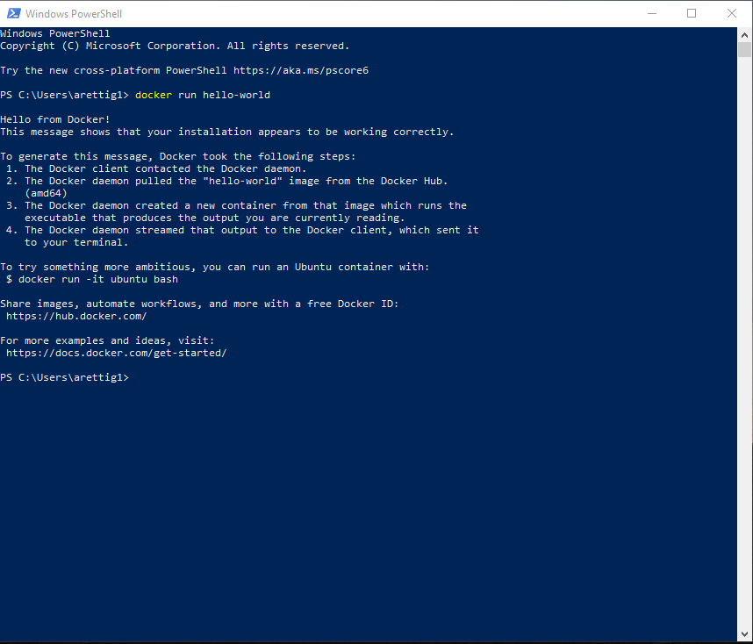

* + 1. Now look in the app to find the image it downloaded for hello-world and the container it created

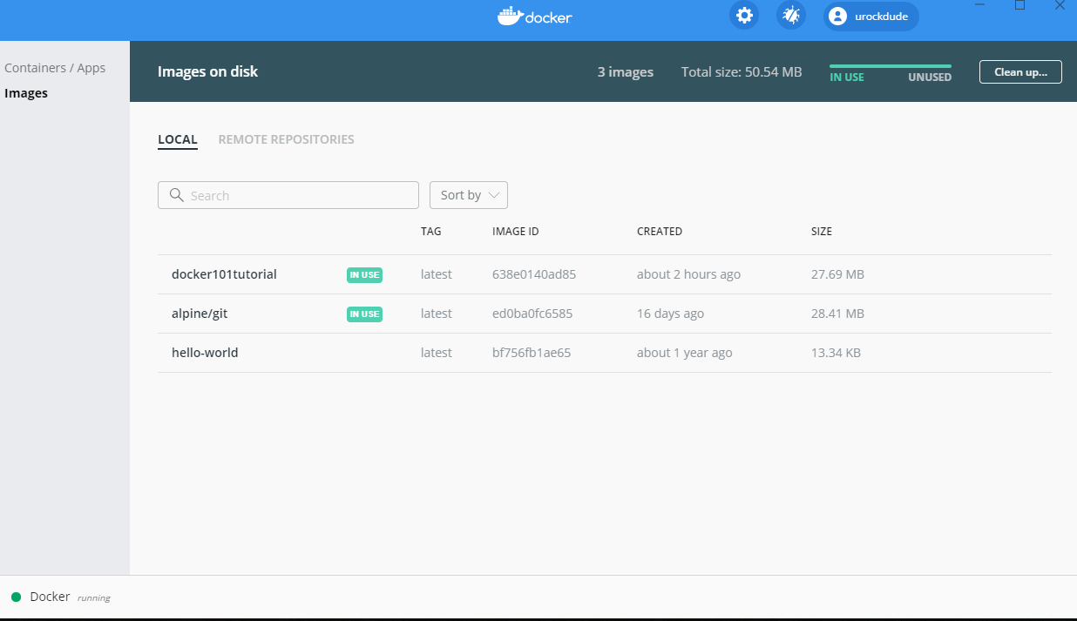

**Once you have docker installed just run the command “docker info” in command line or PowerShell and take a screenshot with your desktop in the background as well. Use this screen shot as your submission for a completed Homework 2.**

1. Docker Tutorial (this part is optional)
   1. Now you can go ahead and do the tutorial if you want.
   2. Do steps 1-3 to setup a webserver locally with a tutorial
      1. Step 4 is for uploading and can be skipped

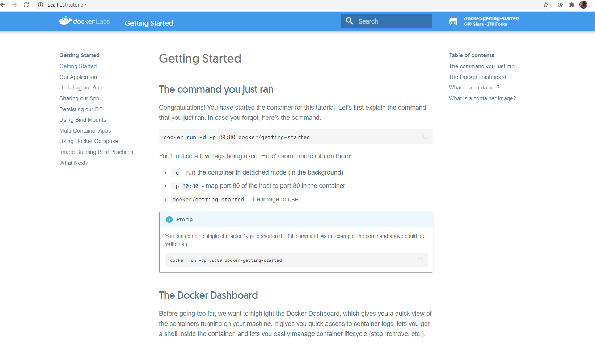

Additional Information: <https://docs.docker.com/docker-for-windows/>

Alternate Instructions: <https://hub.docker.com/editions/community/docker-ce-desktop-windows>